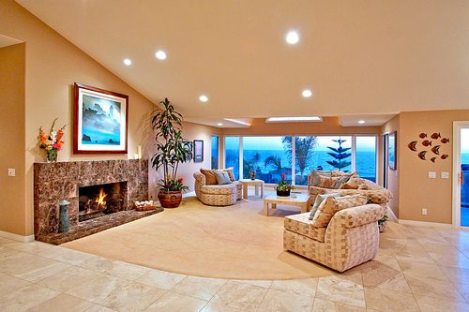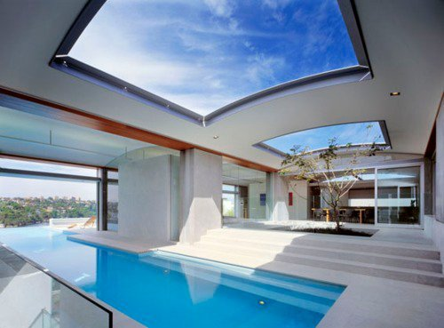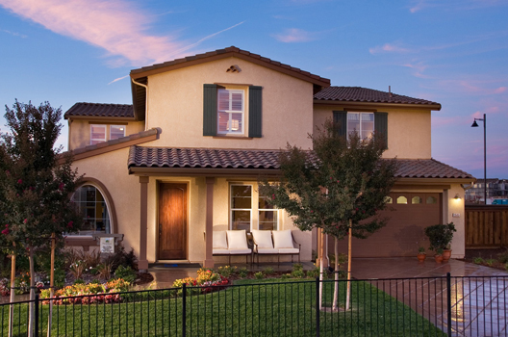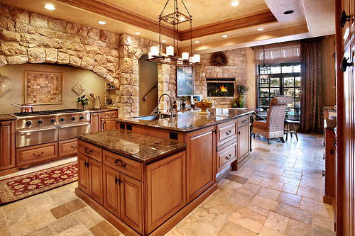

**Del Mar**

A State of the Art house; with an ocean view. Has an indoor/ outdoor pool, bungee/ recreation room and a Gourmet Marble Kitchen. Marble and Brazilian Cherry wood flooring. With 3 bedrooms, 4 baths and a separate laundry room, this two story wonder in beautiful Del Mar is not one to pass up.

***Offered at $466,697***

[Street Address]