The Tale of the Claw

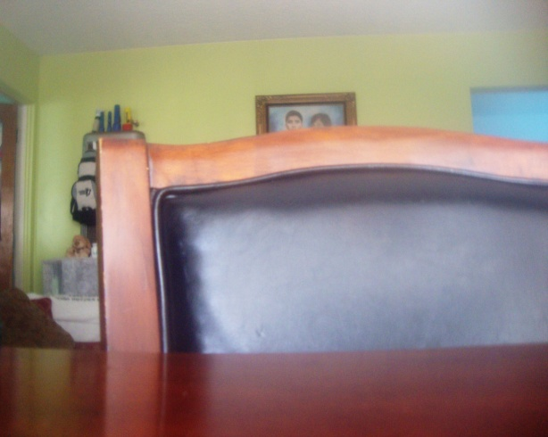
As the quotidian light that appears in the distance every day starts to disappear, I crawl in search of food for I have not found any in two days. In the distance I see something that looks like a caterpillar. I start to bustle before my other relatives or enemies get it. When I arrive I am disappointed to only find a Cheeto surrounded by other crumbs of food the size of my body. Still I thought there might be some fruit I can eat from so I search, but all of a sudden I am picked up into the sky by a bird. I try to defend myself by releasing the liquid in my thorax, but I am unable to move. The bird drops me into a place surrounded by white with a sturdier texture then the Cheeto, and has the shape of a tall, clear, cylinder. I realize that night has arrived quickly and I can hear the stars appear in the sky. I have never heard the stars make such a horrible noise nor see a small amount of them. This white Cheeto starts to move and I find myself in a place I have never been to before. It’s a room that looks like my home because it’s green, but I know that I am far away from there right now. As I am trying to figure out how far I am from home I hear the sound of a thud followed by silence. This silence alarms me and I prepare my thorax to spray whatever is coming for me. I am being lifted in the air and forced to leave this white Cheeto but I am trying to hold on for I have no intention of getting out of this place where I feel somewhat safe. I fail to hold on and I am pulled by a great force into a place where I see a relative that looks like me. I am trying to communicate with him but he doesn’t respond, in fact he’s mocking me! Despite the fact that he is mocking me, there is a little guy next to me who seems to be curious about me yet frightened at the same time. I have only seen his type when it rains but he was different. He was a small beetle the color of concrete with some big eyes. I decide to leave him alone and look for a way to escape from my relative that keeps following me everywhere. As I am trying to find a way to escape, I see a couple of fish and I also notice that the little beetle that seemed frightened of me was crawling to the top of this prison we were in. It seems that he found a way to get out or maybe he’s just running away from me. Either way I try to follow him by crawling to the top too, but I keep falling back down. I see that it is impossible to crawl to the top so I decide to take a nap and hope that later I’ll be able to escape. When I wake up from my nap, I see that the beetle has disappeared and left a trail of himself. I start to think that the giants outside did something to him and now they’re coming for me. As a matter of fact one of the giants comes for me and tries to get me out of this prison. I not so sure about leaving so I hold onto whatever I can, but let go and enter another prison the color of a white Cheeto that I was first kidnapped by, only this time I could see blurry images. I am being moved again and I believe its morning because the light that appears every day has just started to creep its way into the sky. While I am being moved I hear another loud thud followed by a lot of jumping movements. It feels like those days where the ground shakes really hard and makes most animals scared. The only difference in this is that it continued for a while, then stopped for a short period of time and continued to move yet not as intense as before. There was a light breeze that reminded me of home and told me we were farther away than before. I start to realize that I might not escape this prison so I wait. I wait for my final destiny and prepare to give my final battle for I don’t know when I’ll be set free.

